ELECtrochemical synthesis of copper oxides and their electrocatalytic properties in direct methanol fuel cells
Anna Ulyankina, Nina Smirnova
Platov South-Russian State Polytechnic University (Novocherkassk Polytechnic Institute), Russia,
E-mail: anya-barbashova@yandex.ru
Introduction
The synthesis of micro/nanoparticles of transition metal oxides with different morphology has attracted a considerable amount of interest because of structure-dependent material properties with potential application in direct methanol fuel cells (DMFCs). Of the different transition metal oxides that are available, copper oxides are a promising material due to their low cost, larger abundance, chemical stability and environmentally friendly nature. The various nanostructured copper oxides have been synthesized using a variety of methods. Electrochemical synthesis under pulse alternating current offers a simple, one-step, room-temperature and relatively cost-effective technique that can be used for large-scale applications.
Experiments
In this paper we investigated the copper oxides which were firstly prepared by means of electrochemical oxidation/dispersion under pulse alternating current of different current densities (0.5; 1.0 and 1.5 A/cm² for CuO_{x}-0.5, CuO_{x}-1.0 and CuO_{x}-1.5 samples, respectively). This technique was also used for synthesis of different metal oxides such as NiO[1] and SnO₂[2].
The obtained materials were investigated by a variety of the methods such as X-ray diffraction, scanning and transmission electronic microscopies, Raman spectroscopy.
The electrocatalytic activity of the copper oxides for methanol oxidation was investigated by cyclic voltammetry (CV). Solutions containing 0.1M NaOH with and without 0.25M CH₃OH were used as the electrolyte.
Results and Discussion
It was shown that the current density has a significant effect on shape, size and composition of the prepared powders. The CuO_{x}-0.5 powder is pure Cu₂O with octahedral particles of 1 μm. When the current density increases the CuO phase appears. The CuO_{x}-1.0 consists of polyhedral particles of Cu₂O (50-400 nm) with small amount of CuO. The CuO_{x} -1.5 particles can probably reveal Cu₂O/CuO core-shell structure[3].
Figure 1 (a,b) shows the CV curves measured at a scan rate of 50 mV/s for the CuO_{x}-0.5, CuO_{x}-1.0 and CuO_{x}-1.5 samples in 0.1M NaOH and (0.1M NaOH+0.25M CH₃OH) electrolytes. It can be seen that after the addition of 0.25 methanol in 0.1M NaOH electrolyte, during the forward scan, the anodic current density remains nearly the same up to 0.4 – 0.47 V and, above this potential, the copper oxide surface is converted into CuOOH in NaOH electrolyte. Also, methanol is oxidized at a certain potential, which forms Cu(OH)₂ and CO₂ with a sharp increase in the anodic current density[4]. This indicates that the electrooxidation of methanol takes place on the surface of the electrodes[4].

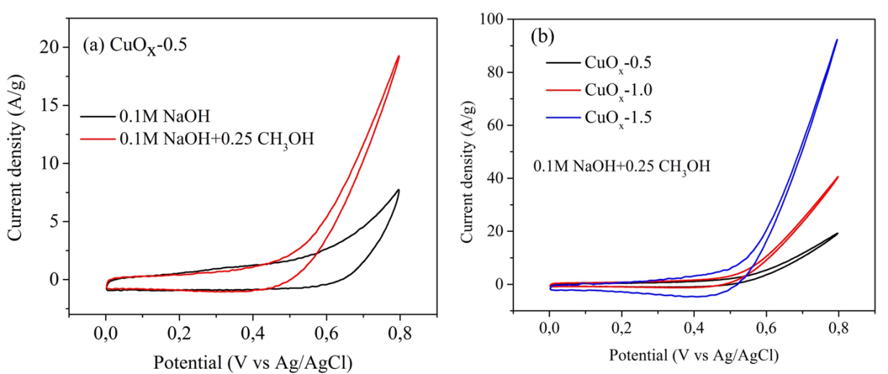
Figure 1 - Cyclic voltammograms (CVs) at a scan rate of 50 mV/s for (a) CuO_{x}-0.5 measured in 0.1M NaOH and (0.1M NaOH+0.25M CH₃OH) and (b) CuO_{x}-0.5, CuO_{x}-1.0 and CuO_{x}-1.5 measured in (0.1M NaOH+0.25M CH₃OH) electrolytes

It is well known that two important parameters for methanol electrooxidation are the onset potential and the anodic current density. The results in Figure 1 show that the onset potentials for all samples are almost similar (0.44, 0.46 and 0.40 V for CuO_{x}-0.5, CuO_{x}-1.0 and CuO_{x}-1.5, respectively). However, the anodic current density of the CuO_{x}-1.5 is much higher than that of the CuO_{x}-0.5 and CuO_{x}-1.0. It may be related to a higher electrocatalytic activity of CuO phase compared to Cu₂O[4]. Moreover, the anodic current density at the methanol oxidation potential for copper oxides may vary depending on the exposed crystal plane. In paper[5] it was shown that plate-like copper exhibits enhanced catalytic activity toward methanol oxidation compared to octahedron-like copper crystals depending on the exposed crystal plane. The results of the electrocatalytic performance clearly indicate that the structure of copper oxides prepared by electrochemical oxidation/dispersion under pulse alternating current has a great effect on electrocatalytic activity in methanol oxidation reaction.

References
1. Leontyeva D.V., Leontyev I.N., Avramenko M.V., Yuzyuk Y.I., Kukushkina Y.A., and Smirnova N.V. Electrochemical dispergation as a simple and effective technique toward preparation of NiO based nanocomposite for supercapacitor application // Electrochimica Acta. 2013. V. 114. P. 356-362.
2. Kuriganova A.B., Vlaic C.A., Ivanov S., Leontyeva D.V., Bund A., and Smirnova N.V. Electrochemical dispersion method for the synthesis of SnO2 as anode material for lithium ion batteries // Journal of Applied Electrochemistry. 2016. V. 46(5). P. 527-538.
3. Ulyankina A., Leontyev I., and Smirnova N. Electrochemical Synthesis and Photocatalytic Activity of Differently Shaped CuOx Particles // Nano Hybrids and Composites. 2017. V. 13. P. 330- 333.
4. Pawar S.M., Kim J., Inamdar A.I., Woo H., Jo Y., Pawar B.S., Cho S., Kim H., and Im H. Multi-functional reactively-sputtered copper oxide electrodes for supercapacitor and electro-catalyst in direct methanol fuel cell applications // Scientific Reports. 2016. V. 6. P. 21310.
5. Venkatasubramanian R., He J., Johnson M.W., Stern I., Kim D.H., and Pesika N.S. Additive-Mediated Electrochemical Synthesis of Platelike Copper Crystals for Methanol Electrooxidation // Langmuir. 2013. V. 29(43). P. 13135-13139.

